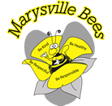
MARYSVILLE ELEMENTARY SCHOOL
PAC MEETING AGENDA
JANUARY 17, 2024

- MINUTES AND AGENDA APPROVAL
- CORRESPONDENCE
- REPORTS
TREASURER
PRINCIPAL

UNFINISHED BUSINESS
- Hot Lunch

NEW BUSINESS
- Kindy/new student bags
- Purdy’s Easter fundraiser

Next Meeting: February 21st, 2024

